
DORCHESTER DRAMA
Newsletter April
2012

Exciting changes for Dorchester Drama

Following the Extraordinary Meeting held in April the membership voted in favour of moving our operations to a new base at Sunninghill School. The facilities, which include a large Music Room plus some smaller rooms, will give us the potential to run multiple activities on Club Night (which has been moved to Wednesday). The new venue, ‘The Place with the Stage’, and the lawns outside the main house give us the opportunity to have flexibility of performance. It is thanks to the Committee and their negotiatons with Sunninghill that we have attained such a good deal for the club. We look forward to developing and growing in partnership with Sunninghill School.

Spring production

The Spring production of ‘Dying for a Drink’ was a huge success at ‘The Place with the Stage’. It was a new departure for Dorchester Drama with a whodunit style play accompanied by a two-course meal. It was a real team effort with largely a young cast, including new comers Paul Lawless and Jess Taylor. It marked a debut for Vince as director for Dorchester Drama, gaining him great reviews. A huge well done to Jane and Georgie who cooked all the food (Jane, your puddings were stunning). Many thanks to the production team who waited on tables and sold the wine. Needless to say it was a great team effort and really brought the members together, as well as making over £1,100. Judging by the numerous comments and plaudits we received, the audience loved it and a number of them requested that we do it again.

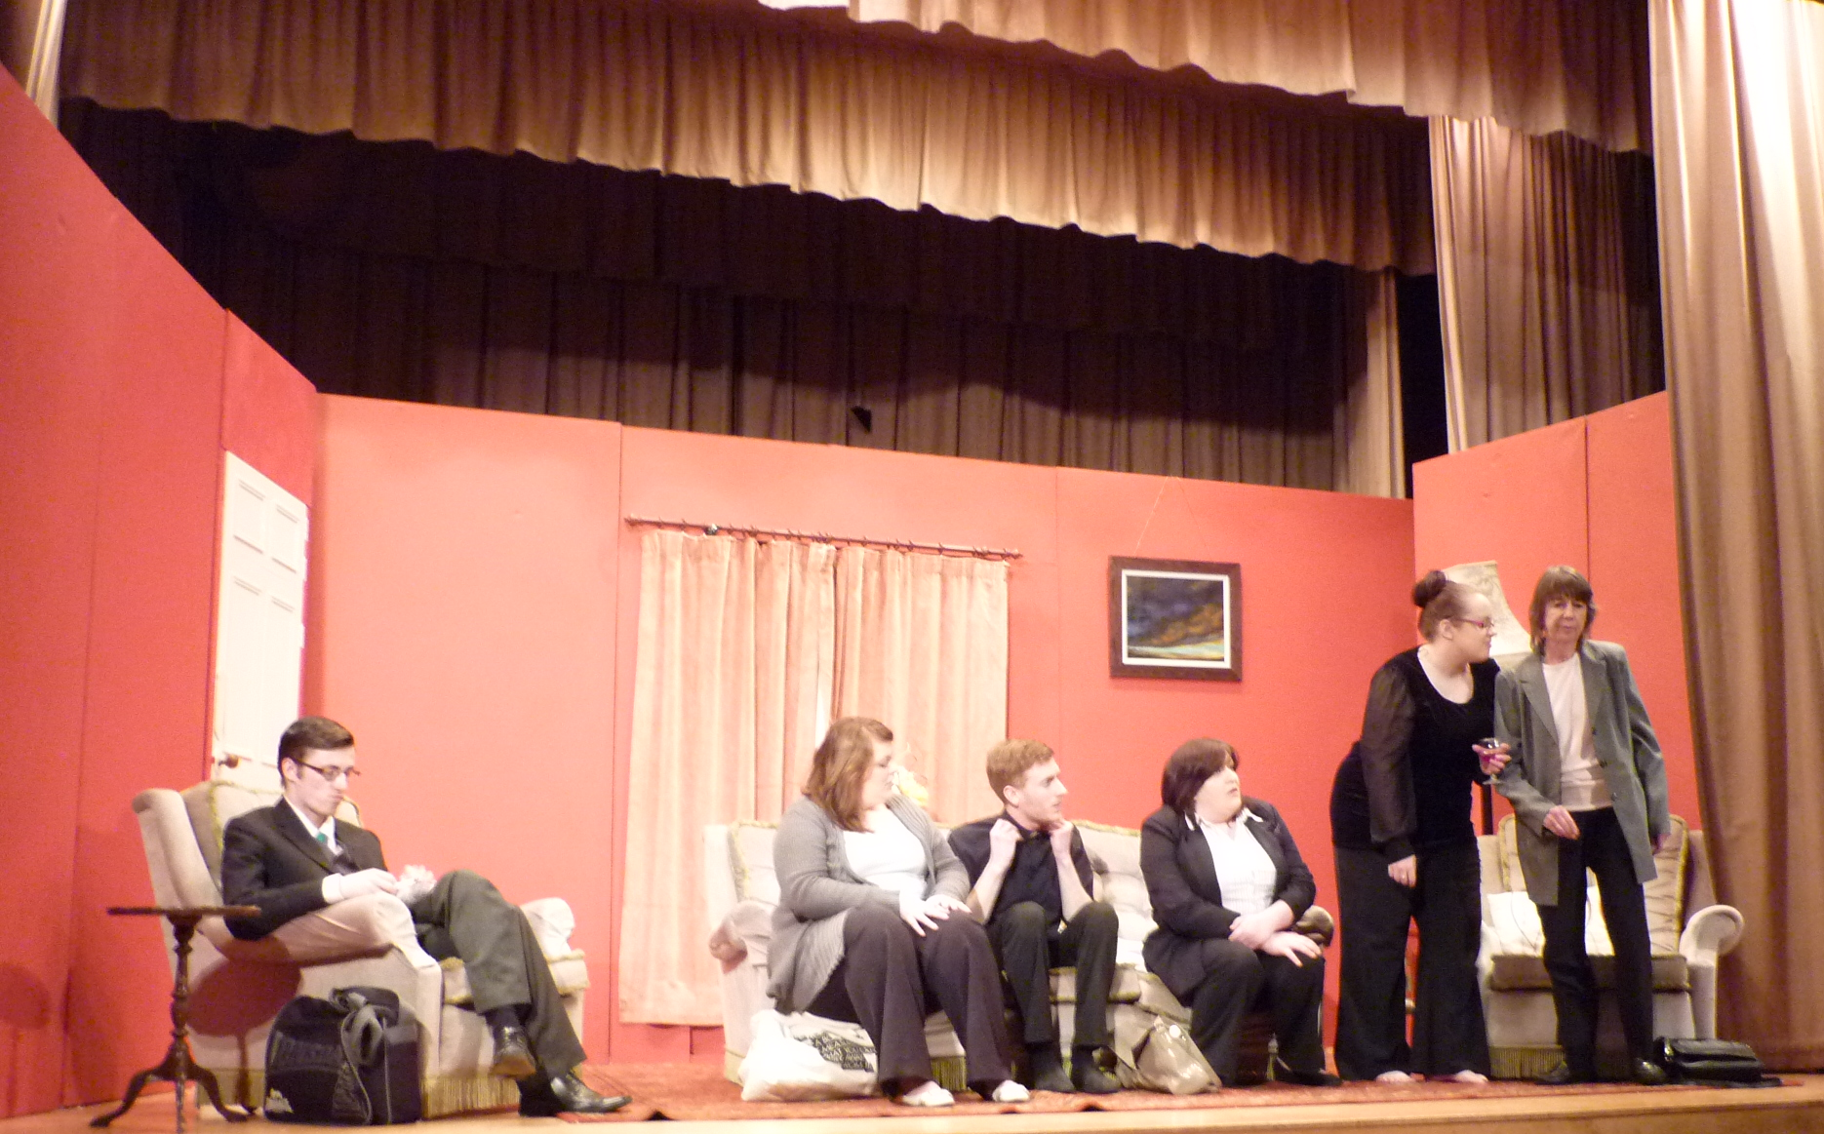
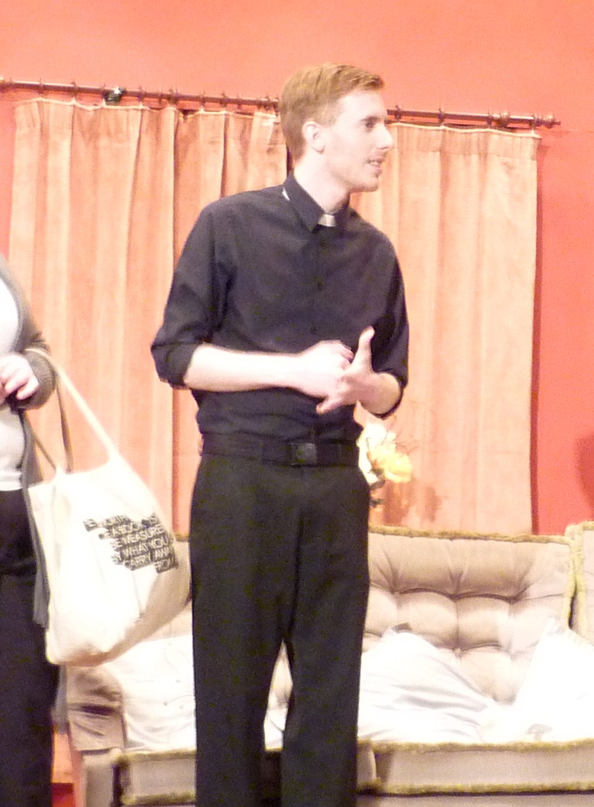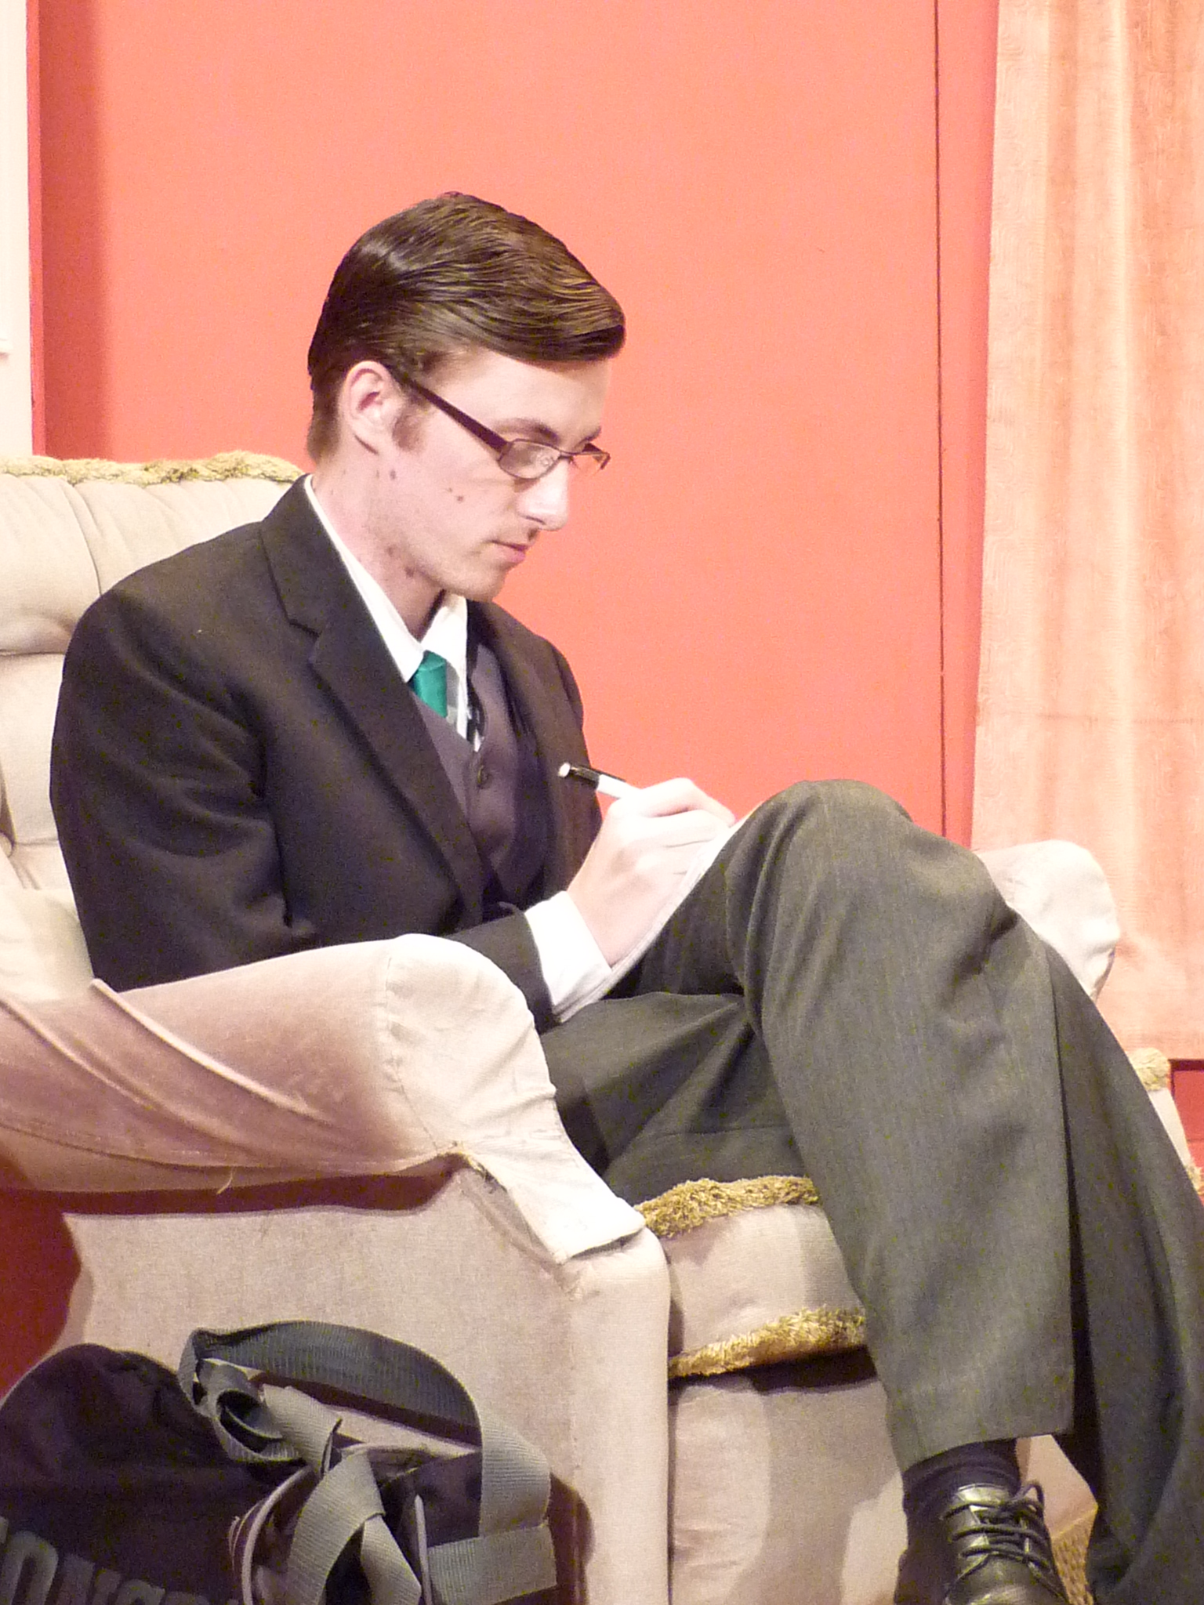

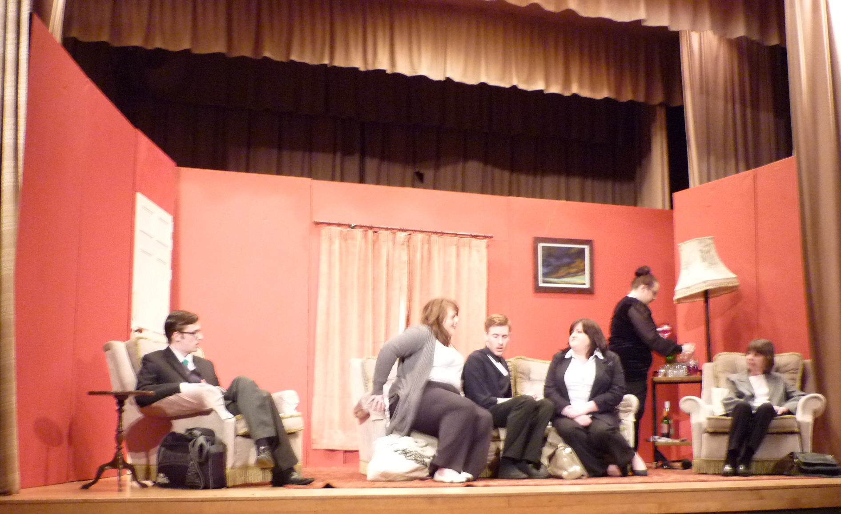

Summer Production

The summer production of ‘Twelfth Night’ will be directed by Anne Reeve and will be performed on Thursday 19th, Friday 20th and Saturday 21st July at either ‘The Place with the Stage’, or if weather permits, in the grounds of Sunninghill School. Auditions will take place at the Sunninghill Music Room on Tuesday 1 May 7:30pm sharp. Past, present and potential new members will be very welcome. It is an ambitious production and Anne is looking to cast 6 men and 5 women.

‘Gaslight’ is to be our November production and will be performed at The Corn Exchange on Thursday 8th, Friday 9th and Saturday 10th November. More details to follow.

Workshops in April

We have also started to run some very successful workshops on Wednesday nights (whilst we don’t have rehearsals) and they have been very well attended. Many thanks go to Anne, Lee and Georgie for running them.

There will hopefully be more workshops after the summer production.

Forthcoming social events

- Skittles Night at the Colliton Club on Saturday 12 May. Tickets cost £4 for members (to include bar food - chips with a choice of sausage, veggie sausage, chicken or scampi). Everyone is welcome (£5 for non-members). Please contact David as soon as possible with food preferences.

- There will be a fund raising quiz night taking place at the beginning of June in aid of the Summer Production. David Reeve will be sending out emails and invites on facebook. This is open to all society members, friends and anyone else we can get! Details to follow.
- The Committee is in the throes of organising a theatre trip later in the year. News of this will be in the next Newsletter. We are looking to take a group to the Royal Bath Theatre to see Trevor Nunn’s adaptation of ‘The Tempest’ towards the end of August. We will email the details shortly.

And finally… the new feature, which will is now a regular item… a profile of one of Dorchester Drama’s members.

An interview with Lee Stroud

Lee, what was the first play you ever performed in?

‘ The Crucible’ in 1971 where I played Mary Warren

What was your most demanding role?

Lady Macbeth in a University production.

What has been your favourite (non Dorchester Drama) play to perform in?

Prospero in ‘The Tempest’ (yet another male role!!).

What has been you favourite role in a Dorchester Drama production?

It’s a very close thing between Captain Smollett in ‘Treasure Island’ or Brutus in ‘Julius Caesar’.

Since you have been with Dorchester Drama what has been your favourite production?

‘Treasure Island’ was a great production and great fun to be in.

Who is your favourite playwright and favourite play?

I love Shakespeare but my favourite play is ‘The Crucible’ by Arthur Miller

What role would you love to play?

Katherine in ‘Taming of the Shrew’.

What have you enjoyed watching on the West End Stage or elsewhere?

It’s difficult to separate between ‘Les Miserables’, ‘The Phantom of the Opera’ and ‘Love Never Dies’.

What have you been proud of directing?

‘The Voyage’ [a play that I wrote]

And finally what would you like to see Dorchester Drama trying to perform?

Productions that take into account that we have a lot of females so won’t have problems casting. Family shows and pantomimes at Christmas would be good. We could also use our new space to write a murder mystery for next March (no Royalties to pay then!). Perhaps we could be the first group to do an all female version of ‘The Crucible’!

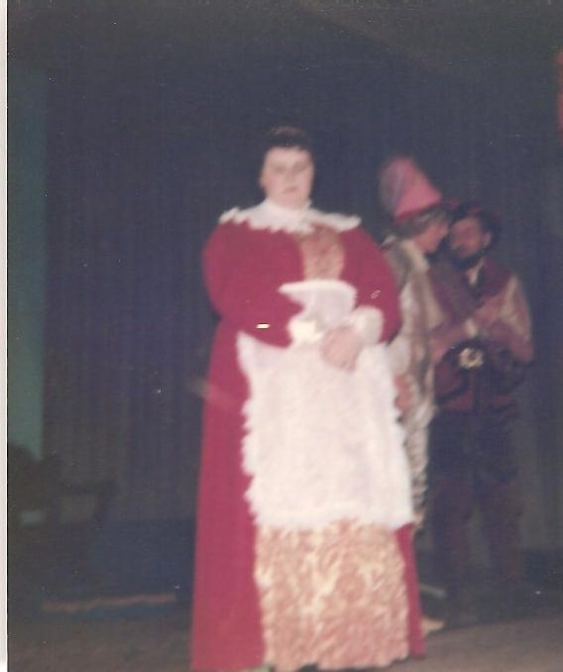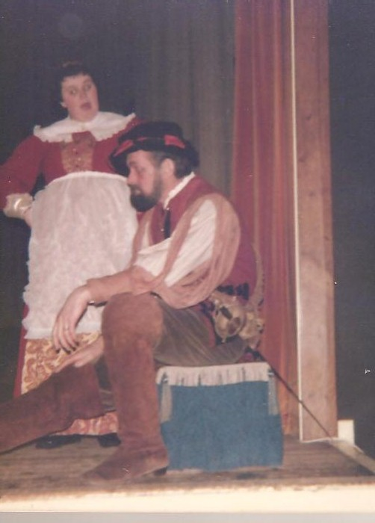
Lee playing Maria in SPADS (St Paul’s Amateur Dramatic Society) 1976 Production of ‘Twelfth Night’ at Letchworth Town Hall

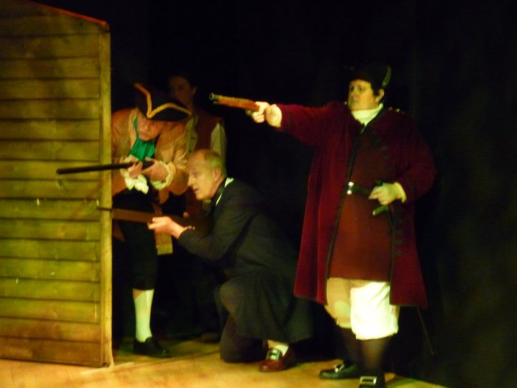
Lee as Captain Smollett in ‘Treasure Island’ (2009)

Thank you for asking these questions!

